Flat shading

📘 Definition
# Source: AI Source: Provided by: [Data Path: Persons Table -> ID Column: 1, Name_En Column: Motasem Essam] -> From: [ChatGPT] on [5/2/2026]
Flat shading is a shading technique in computer graphics where each surface (polygon/face) is filled with one single color or brightness level.
It does not smooth out light changes across the surface, so each face looks flat and distinct.

🧊 How flat shading works
# Source: AI Source: Provided by: [Data Path: Persons Table -> ID Column: 1, Name_En Column: Motasem Essam] -> From: [ChatGPT] on [5/2/2026]
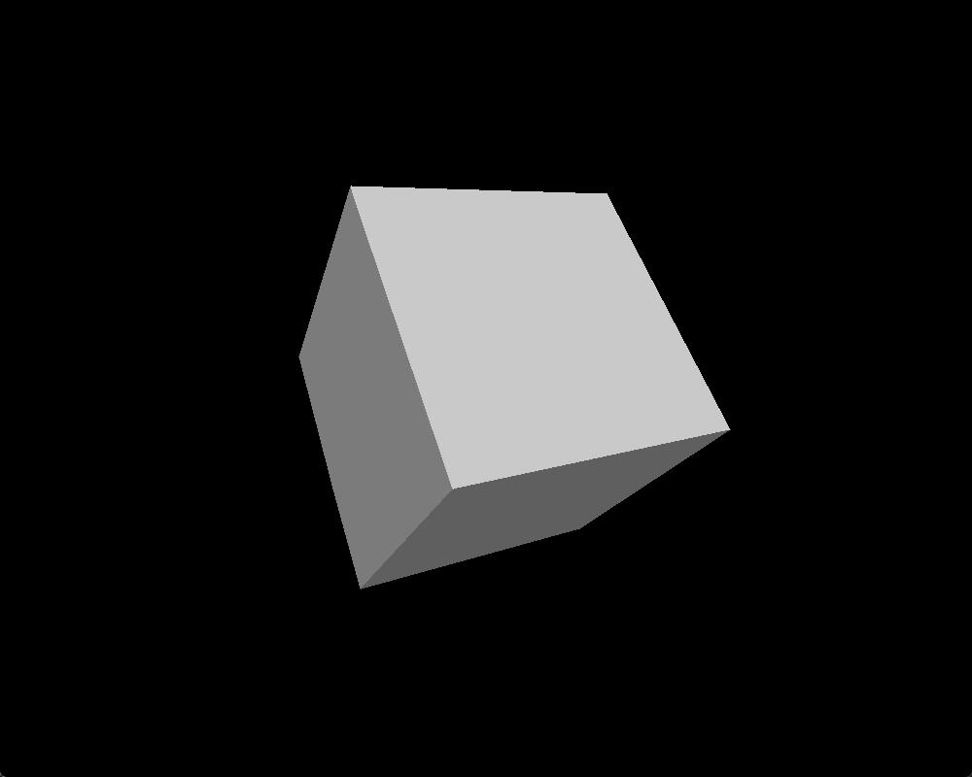
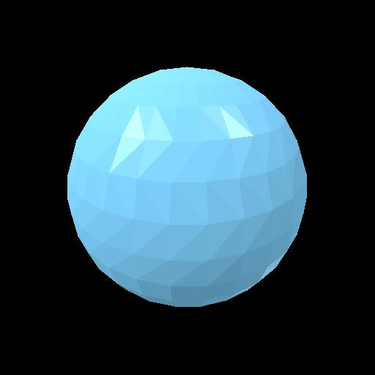
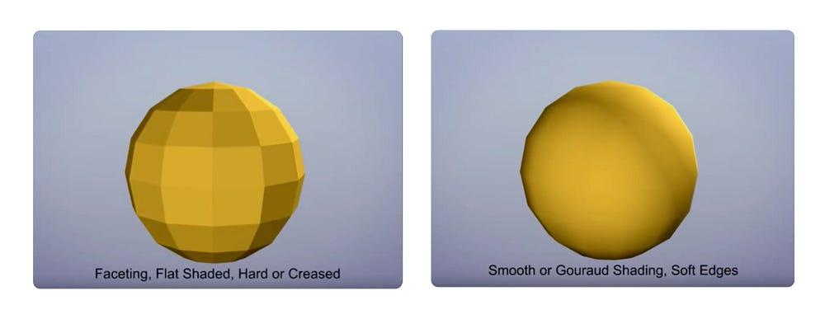
- Light is calculated once per face (polygon)
- The entire face gets one uniform color
- No smooth transition between light and dark areas
- Edges between faces are clearly visible

🧠 Simple example
# Source: AI Source: Provided by: [Data Path: Persons Table -> ID Column: 1, Name_En Column: Motasem Essam] -> From: [ChatGPT] on [5/2/2026]
Think of:
- 📦 A rubik’s cube → each side has one solid color
- 🔺 A low-poly 3D object → you can clearly see each triangle face

🎮 Where flat shading is used
# Source: AI Source: Provided by: [Data Path: Persons Table -> ID Column: 1, Name_En Column: Motasem Essam] -> From: [ChatGPT] on [5/2/2026]
- 🎮 Old or low-poly video games
- 🧪 Scientific or simple simulations
- 🧑‍💻 Debugging 3D models (to see geometry clearly)
- 🎨 Stylized or minimalist art

⚙️ Key features
# Source: AI Source: Provided by: [Data Path: Persons Table -> ID Column: 1, Name_En Column: Motasem Essam] -> From: [ChatGPT] on [5/2/2026]
- 🧊 One color per surface
- ✂️ Clearly visible edges between faces
- ⚡ Fast and simple to compute
- 🎯 Less realistic, more geometric look

🚀 In short:
# Source: AI Source: Provided by: [Data Path: Persons Table -> ID Column: 1, Name_En Column: Motasem Essam] -> From: [ChatGPT] on [5/2/2026]
Flat Shading = a shading method where each surface of a 3D object has a single uniform color, making it look faceted and simple.

